I
n this session we will look at what is sub processes and how it functions ?.

In BPMN, a sub-process is a compound activity that represents a collection of events, tasks, gateways, sequence flows and sub-processes. Generally, we create BPMN diagrams to communicate processes with others. To facilitate effective communications, we really do not want to make a business process diagram too complex. By using sub-processes, you can split a complex process into multiple levels, which allows you to focus on a particular area in a single process diagram.
Sub-Processes allow hierarchical modeling. Many modeling tools allow Sub-Processes to be collapsed, hiding all the details of the Sub-Process, resulting in a high-level, end-to-end overview of the business process.

Camunda Sub Processes and Embedded subprocess
A Sub-Process creates a new scope for events. Events that are thrown during execution of the Sub-Process can be caught by a boundary event on the boundary of the Sub-Process, creating a scope for that event limited to the Sub-Process.
A Sub-Process can only have one none start event; no other start event types are allowed. A Sub-Process must at least have one end event.

Sub-Processes are usually used for the following situations:
- To break down a diagram and make diagrams more readable and logical
- To describe a repeated activity
- Can be easily modified for other uses later

Following are the sub processes supported by camunda

- Embedded Subprocess
- Call Activity
- Event Subprocess
- Transaction Subprocess

Embedded Subprocess
An embedded subprocess is an activity that contains other activities, gateways, events, etc., which itself forms a process that is part of a bigger process. A subprocess is completely defined inside a parent process.

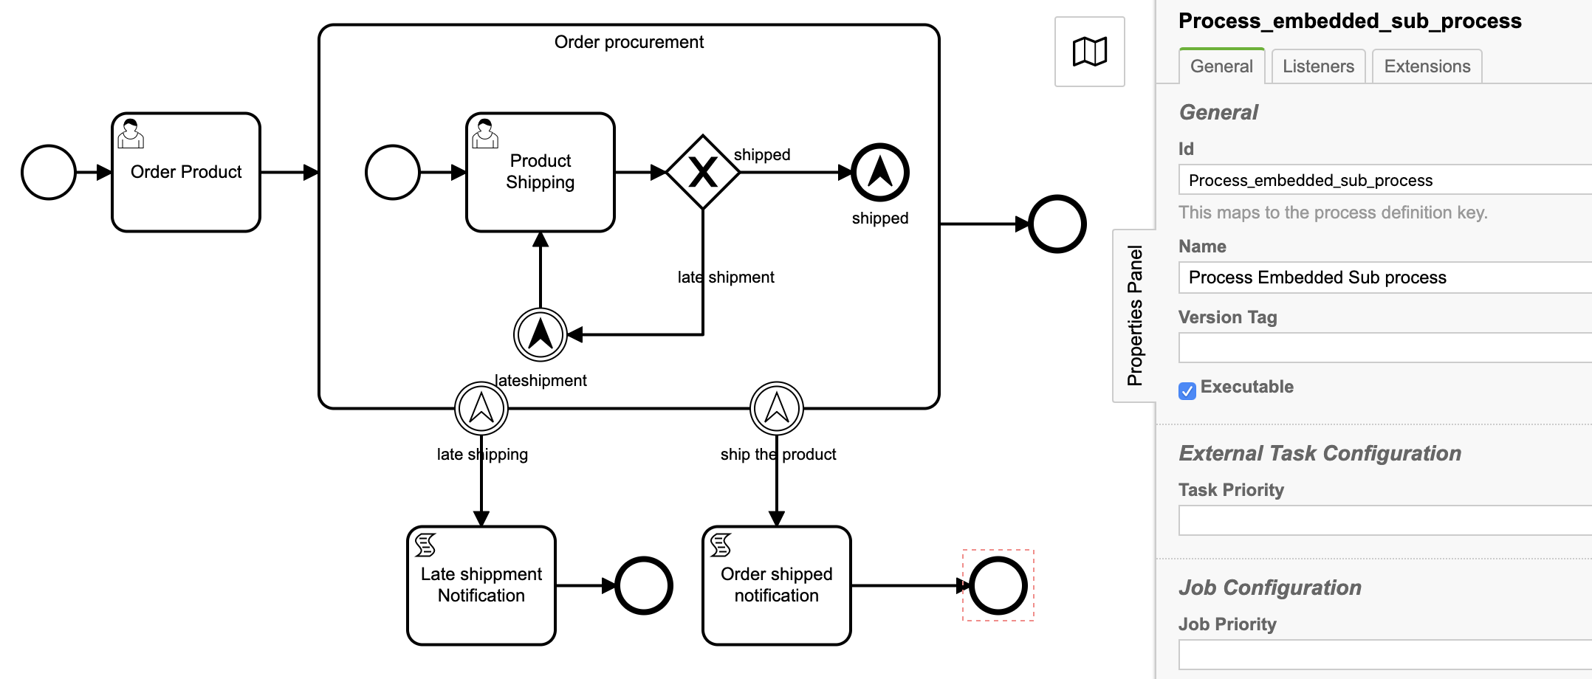
1. Lets demonstrate embedded subprocess using below diagram.

Process properties
Id: Process_embedded_sub_process
Name: Process Embedded Sub process

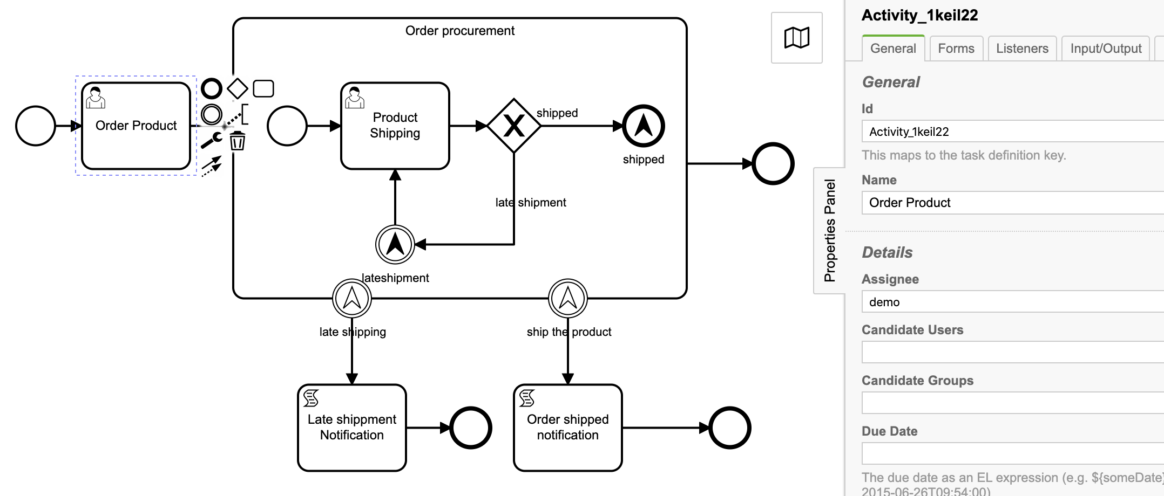
2. User task: Order Product
Id: Activity_1keil22
Name: Order Product
Assignee: demo

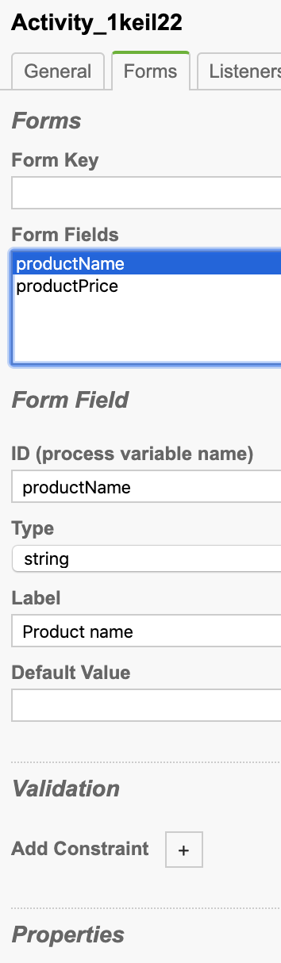
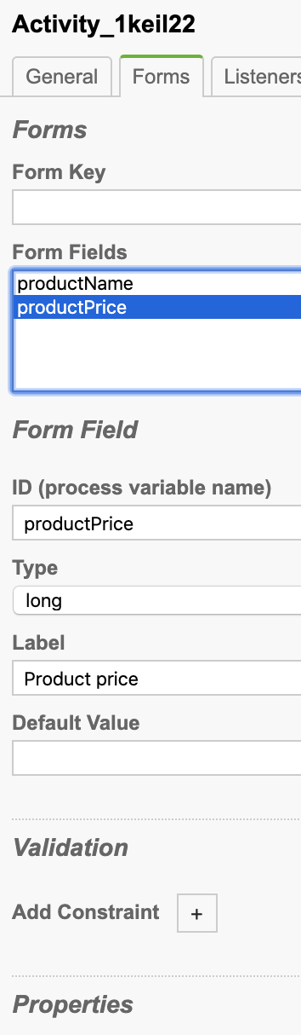
Task form

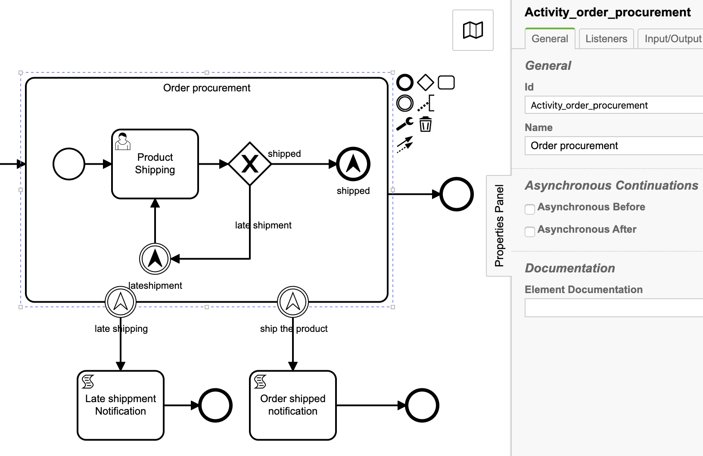
3. Embedded subprocess
Id: Activity_order_procurement
Name: Order procurement

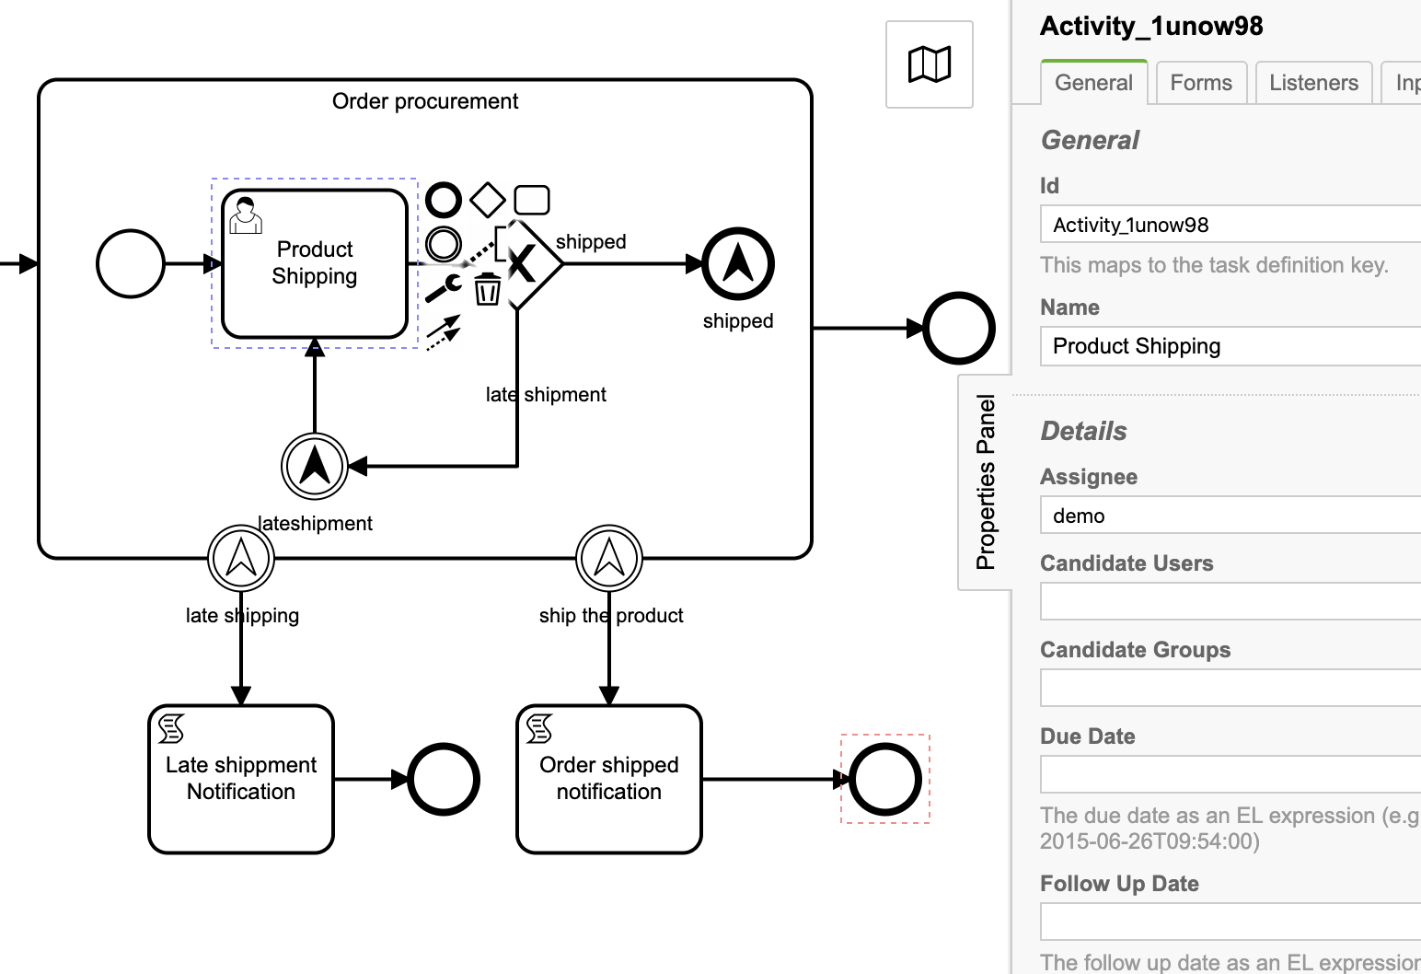
4. Embedded sub process user task: Product Shipping
Id: Activity_1unow98
Name: Product Shipping
Assignee: demo

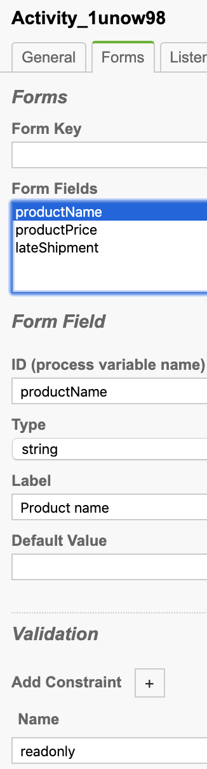
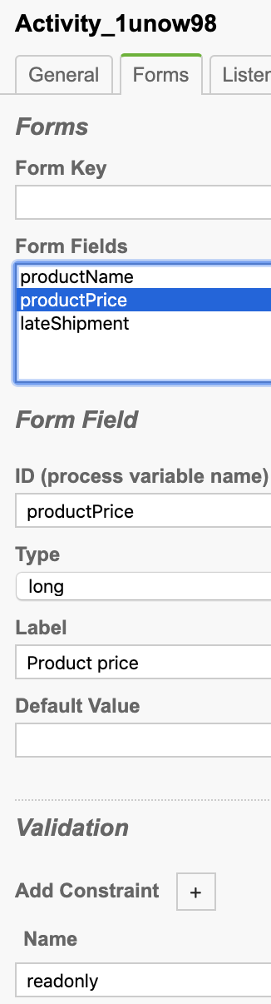
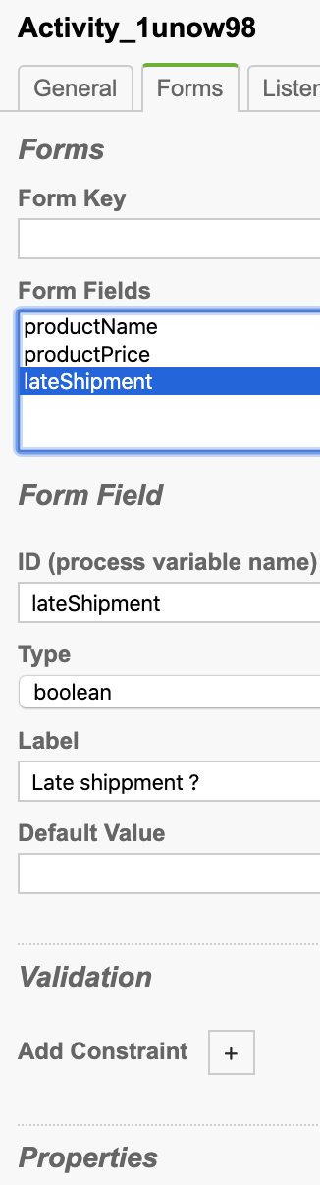
Task form

4. Sequence flows
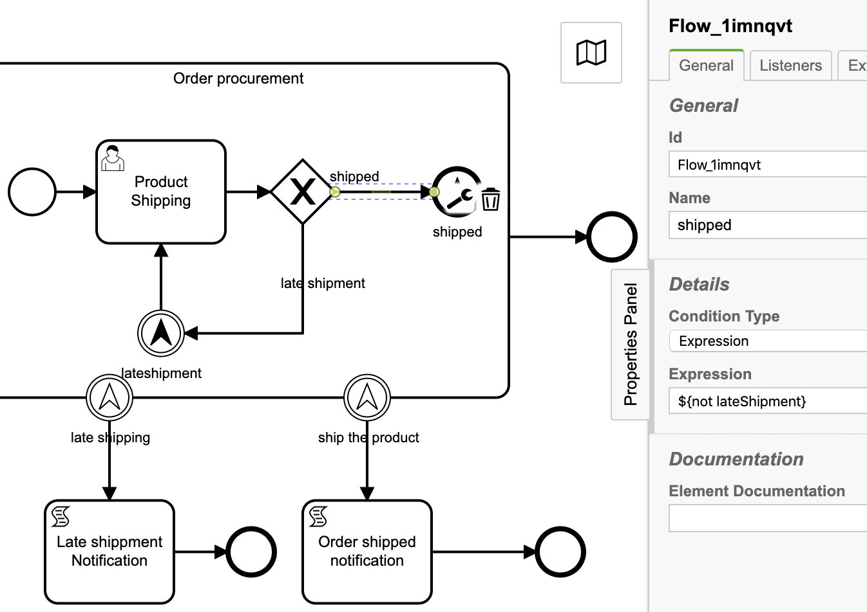
Condition: shipped

Id: Flow_1imnqvt
Name: shipped
Condition Type: Expression
Expression: ${not lateShipment}

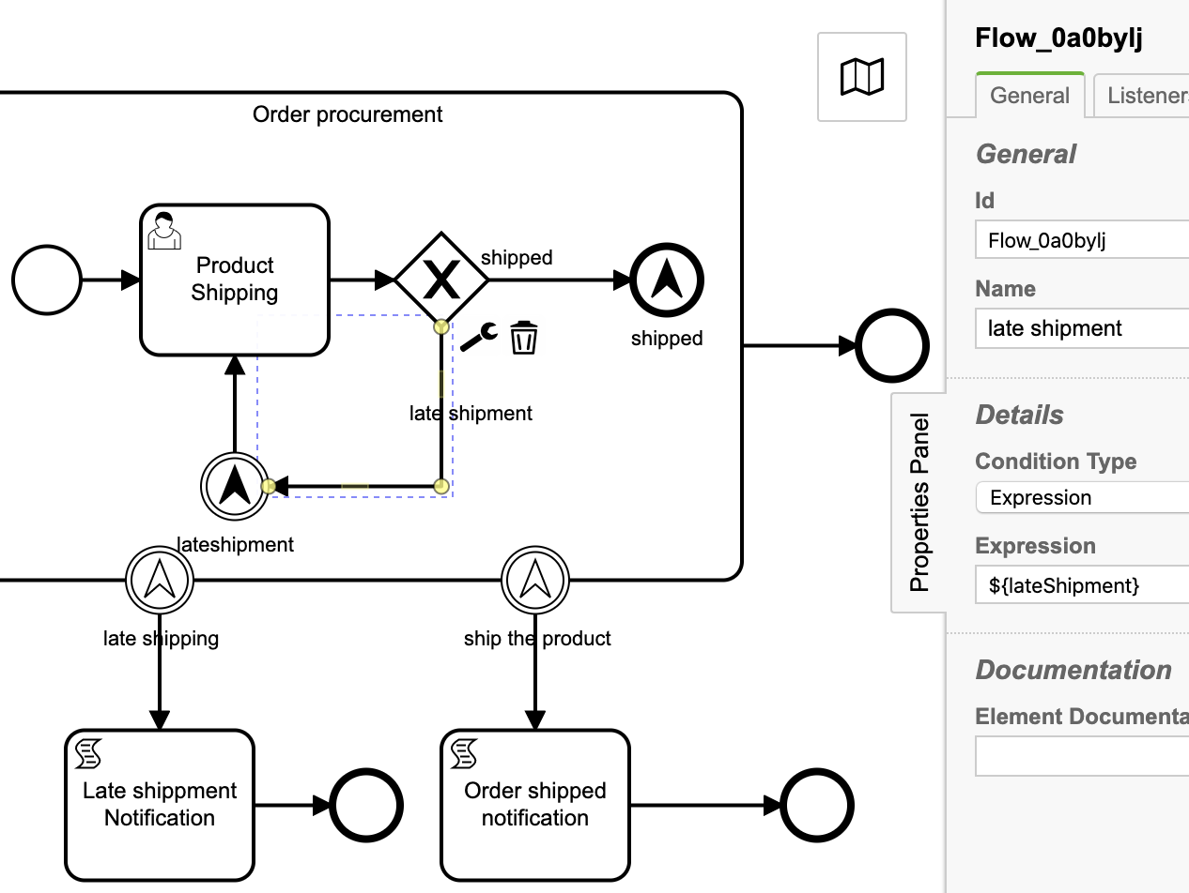
Condition: late shipment

Id: Flow_0a0bylj
Name: late shipment
Condition Type: Expression
Expression: ${lateShipment}

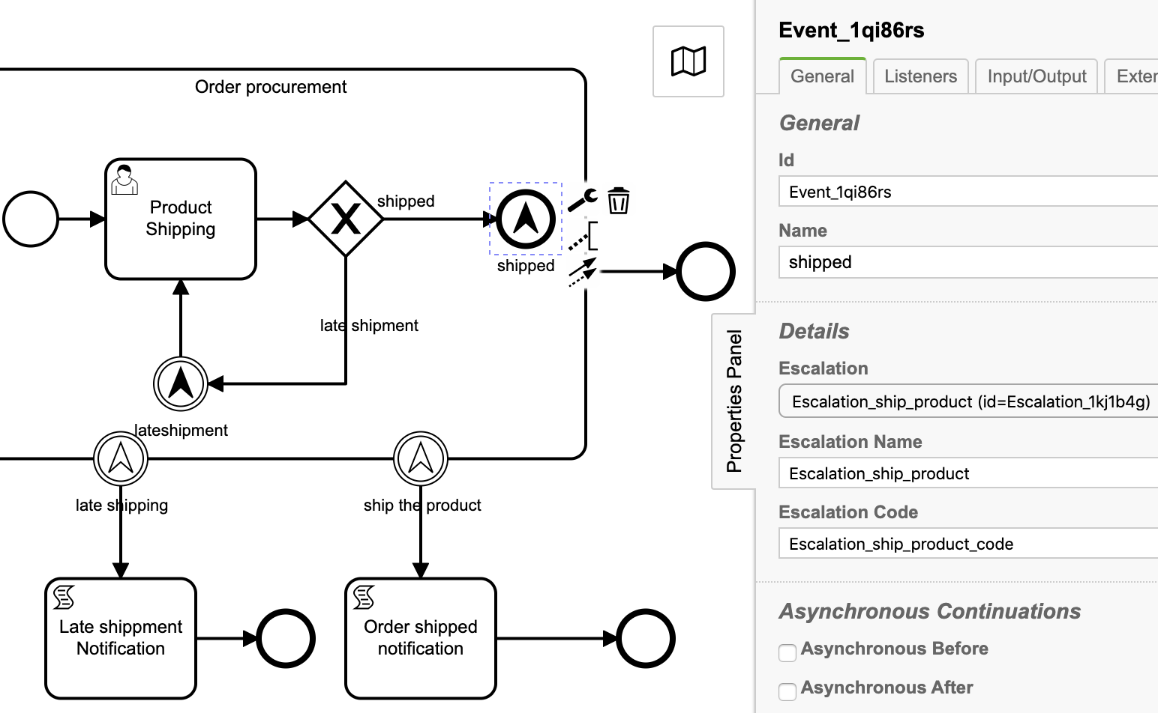
5. Escalation end event: shipped
Id: Event_1qi86rs
Name: shipped
Escalation: Escalation_ship_product (id=Escalation_1kj1b4g)
Escalation Name: Escalation_ship_product
Escalation code: Escalation_ship_product_code

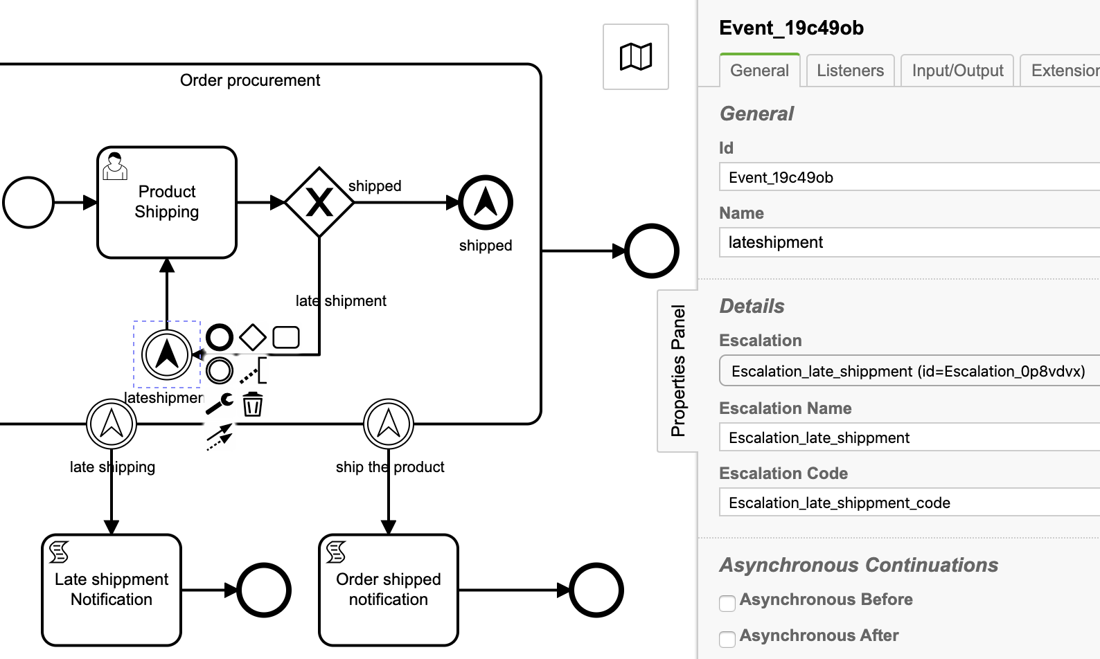
6. Escalation intermediate throw event: lateshipping
Id: Event_19c49ob
Name: lateshipment
Escalation: Escalation_late_shippment (id=Escalation_0p8vdvx)
Escalation Name: Escalation_late_shippment
Escalation code: Escalation_late_shippment_code

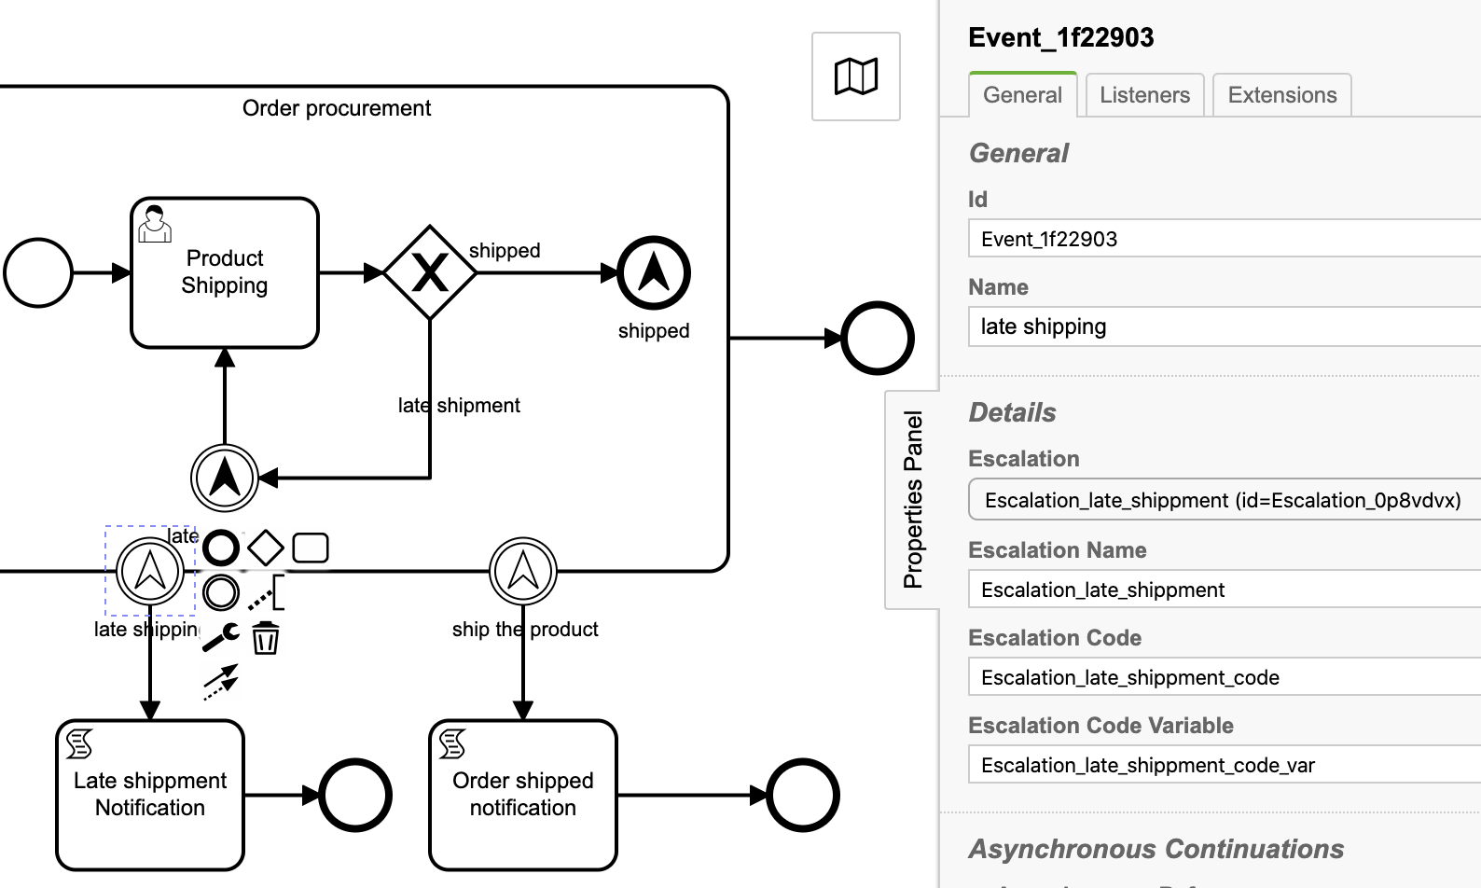
7. Boundary escalation event: late shipping
Id: Event_1f22903
Name: late shipping
Escalation: Escalation_late_shippment (id=Escalation_0p8vdvx)
Escalation Name: Escalation_late_shippment
Escalation code: Escalation_late_shippment_code
Escalation variable: Escalation_late_shippment_code_var

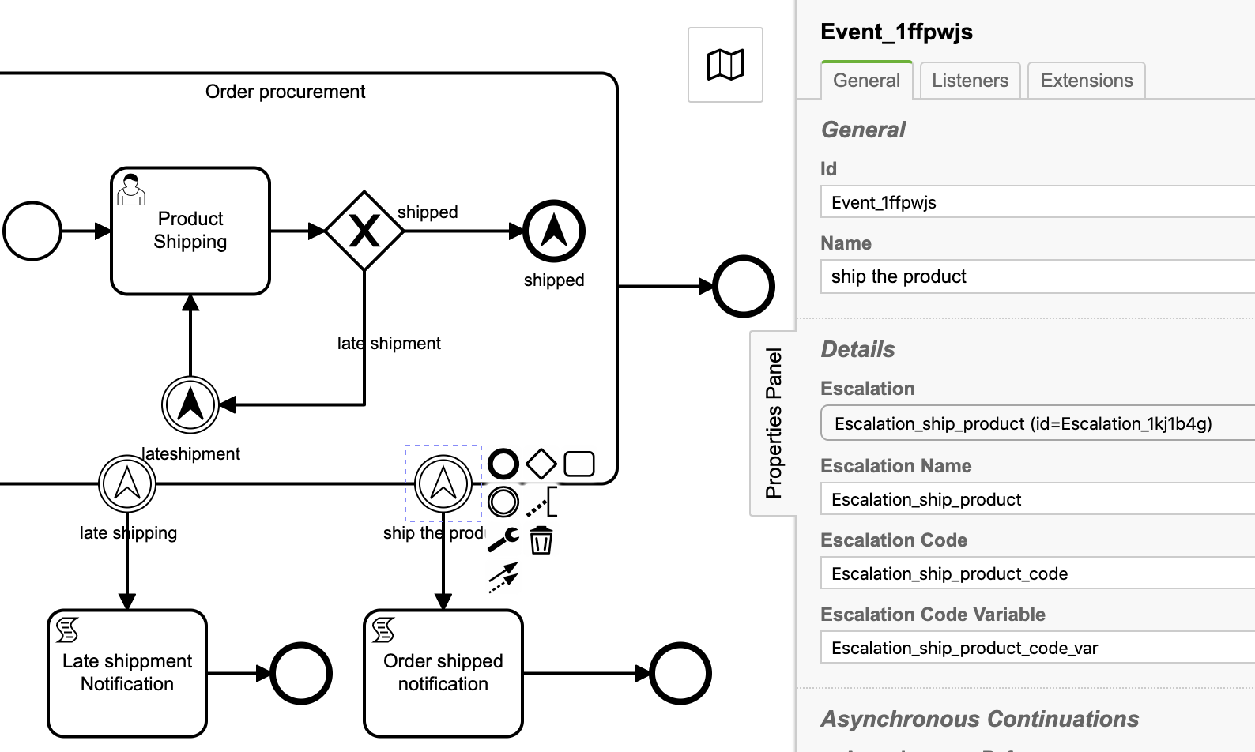
8. Boundary escalation event: ship the product
Id: Event_1ffpwjs
Name: ship the product
Escalation: Escalation_late_shippment (id=Escalation_1kj1b4g)
Escalation Name: Escalation_ship_product
Escalation code: Escalation_ship_product_code
Escalation variable: Escalation_ship_product_code_var

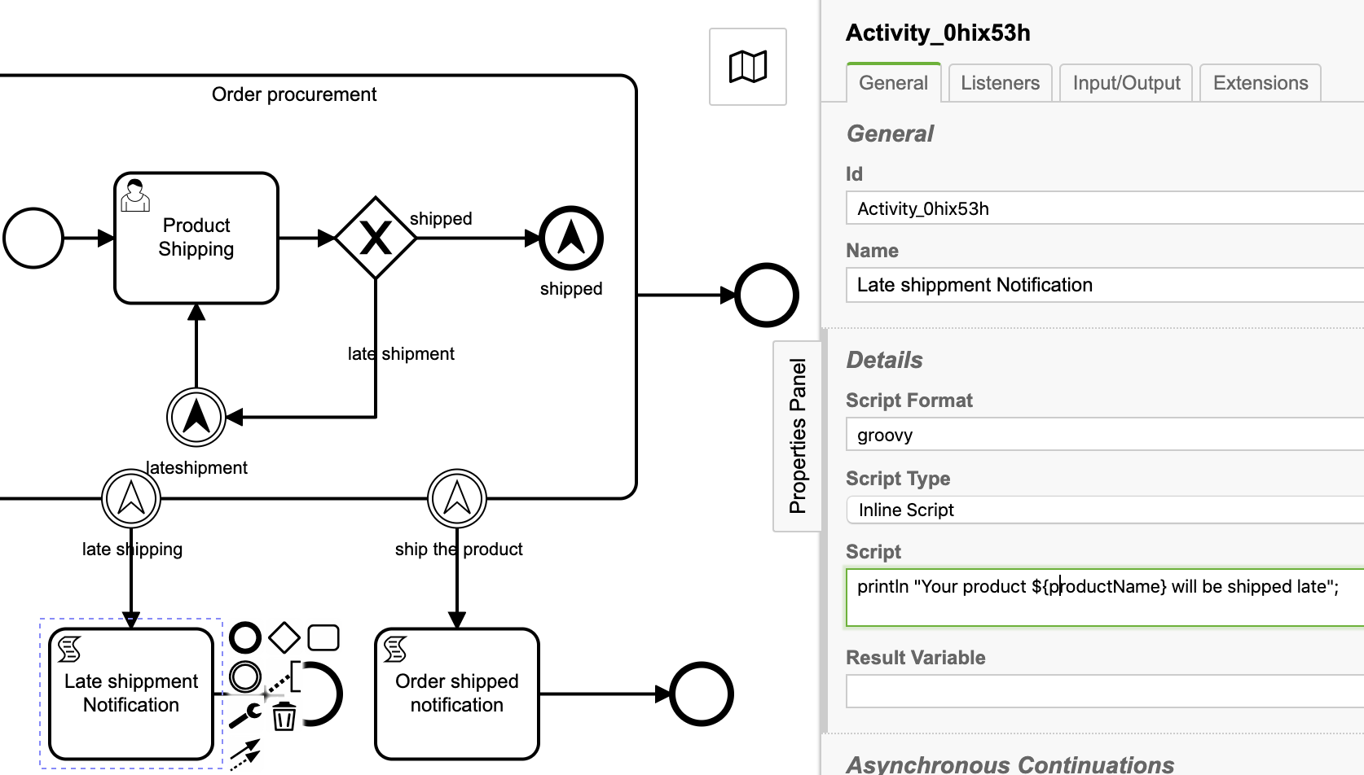
9. Script task: Late shippment Notification
Id: Activity_0hix53h
Name: Late shippment Notification
Script Format: groovy
Script Type: Inline Script
Script:
println "Your product ${productName} will be shipped late";

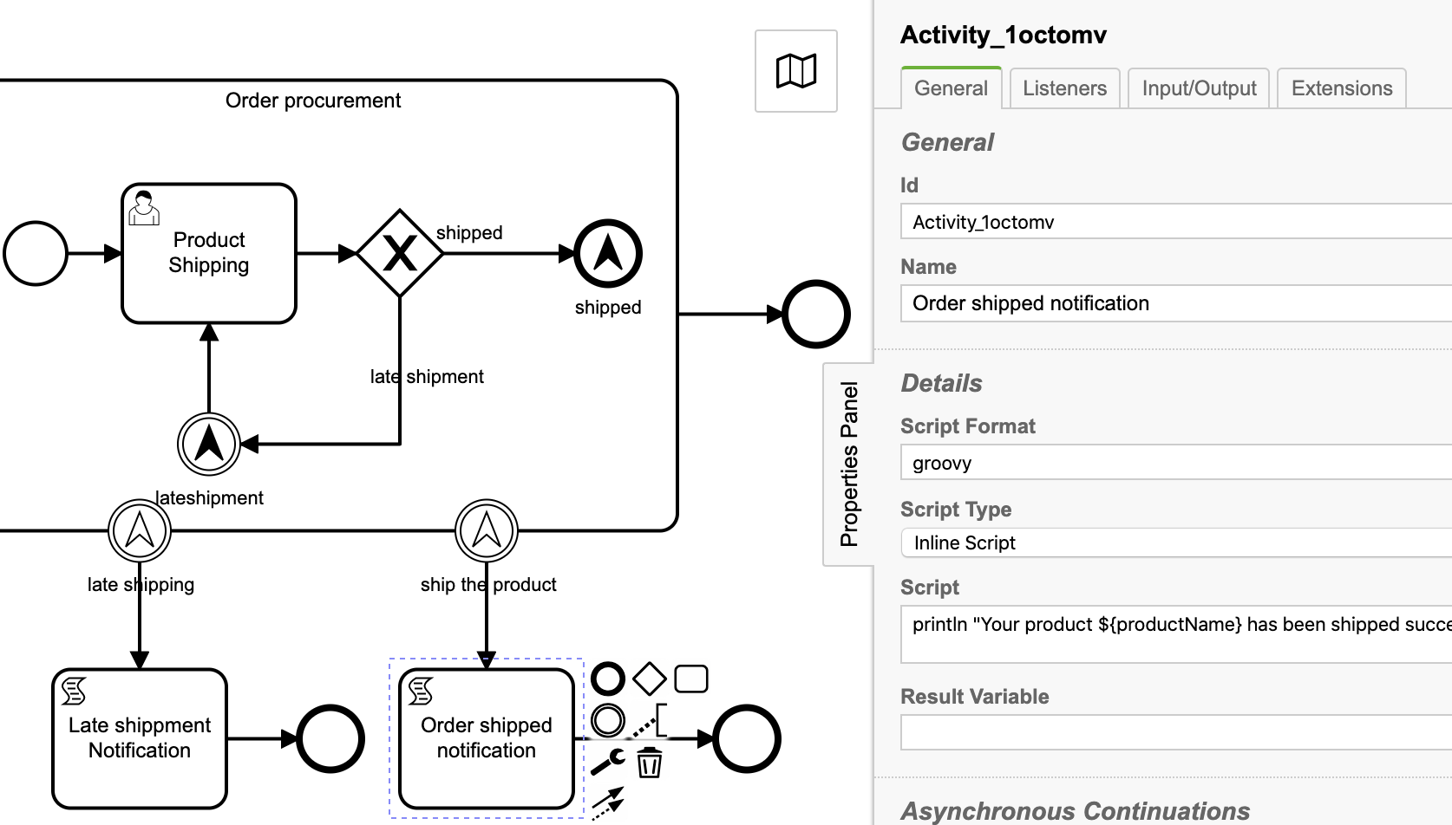
9. Script task: Order shipped notification
Id: Activity_0hix53h
Name: Late shippment Notification
Script Format: groovy
Script Type: Inline Script
Script:
println "Your product ${productName} has been shipped successfully”;

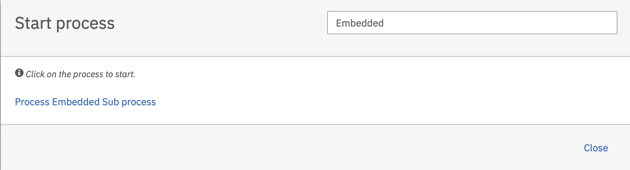
Deploy start the process
Hit the Process Embedded Sub process and then hit the Start button to start the process.

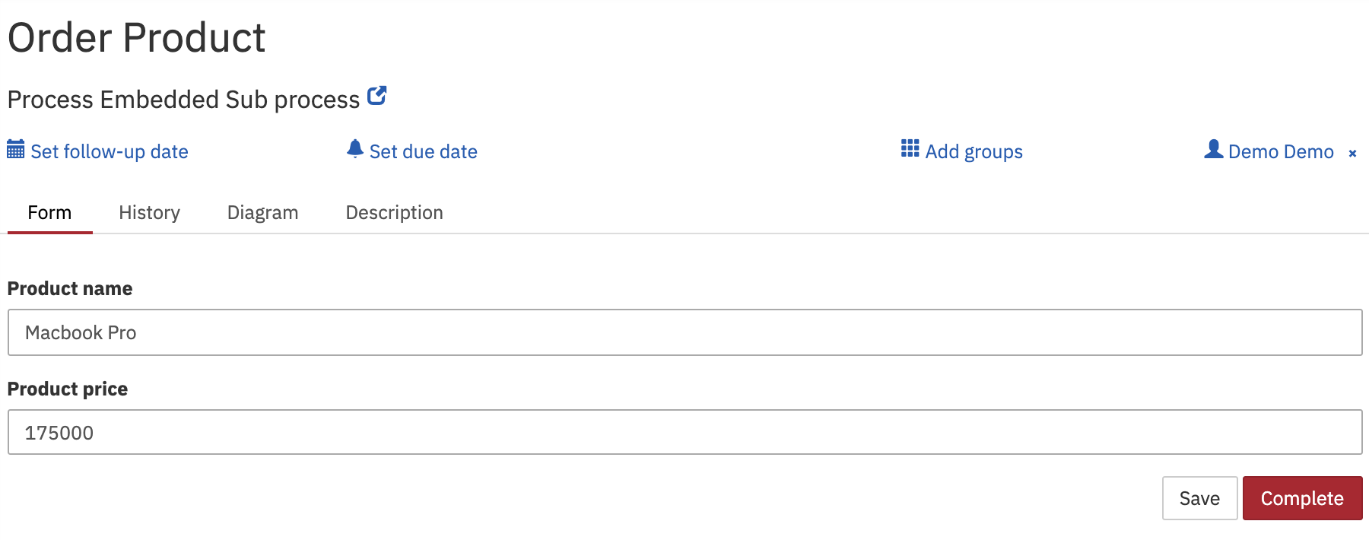
As per process definition user task Order Product will get created.
Fill-up the task form and hit the Complete button to complete the task.

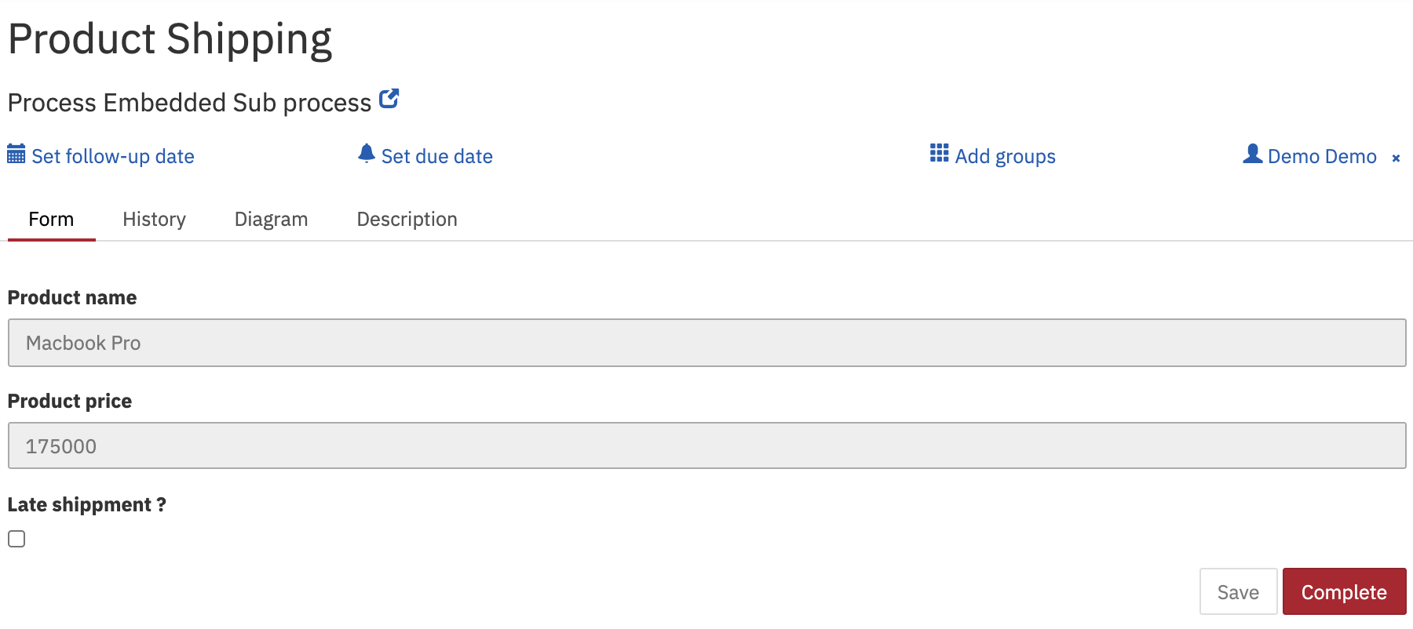
As per process definition on completion of Order Product task, Embedded subprocess user task Product Shipping will get created.

Keep Late shipment checked to trigger late shipment escalation intermediate event. So as a result it will trigger intermediate throw escalation event late shipment and the same is received by boundary escalation event late shipment and then script task Late shippment Notification will get executed.

Observe the tomcat console log
Your product Macbook Pro has been shipped successfully

